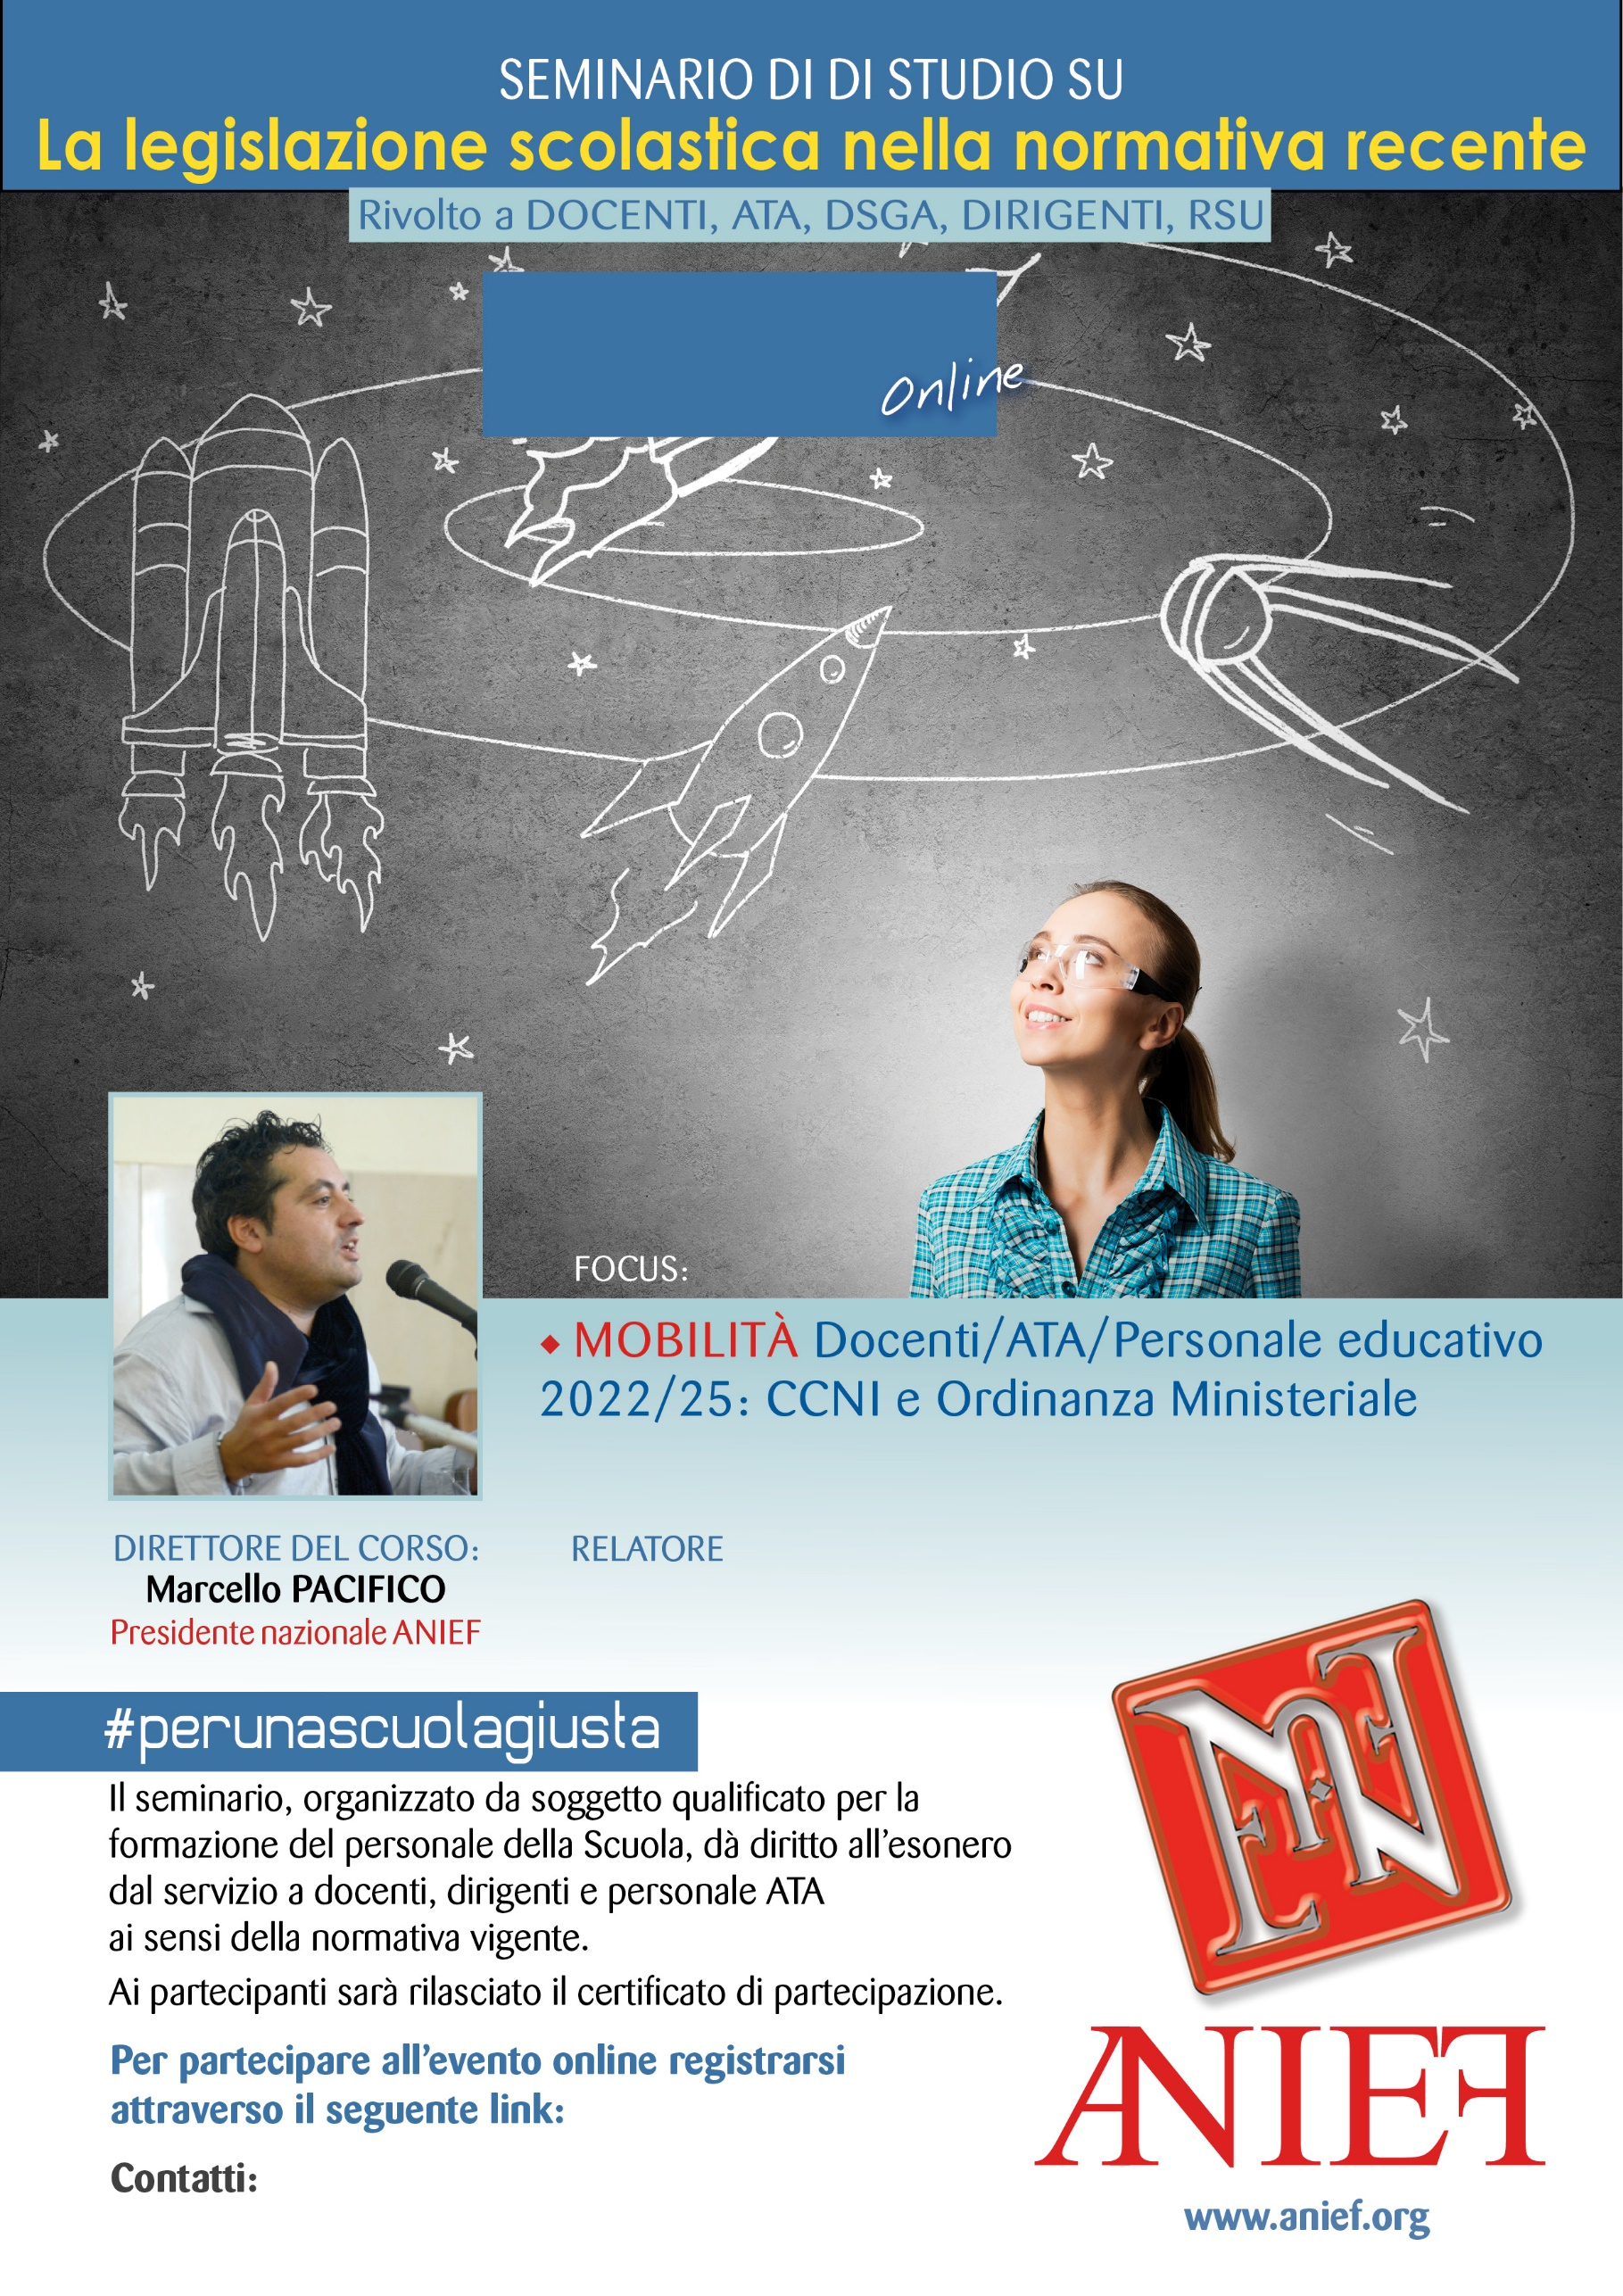

LINK DIRETTA: <https://anief.org/component/anief/dettaglievento?id=75049>

[emiliaromagna@anief.net](file:///C:\Users\amministrazione3\AppData\Local\Microsoft\Windows\INetCache\IE\YH8FG1AA\emiliaromagna@anief.net)

FABIANA BRUNO

EMILIA ROMAGNA

11/03/2022 ORE 11:00 – 13:00